Space Flight Personal Site Content plan

**Topic and idea plan:**

1. **Site Purpose:** My site will be used as a reference guide for statistics, history, and comparisons between space launch providers. It will be in depth and detailed to give all needed information in easily found formats throughout the site.
2. **What questions can be answered:** Simple statistical or historical questions on any of the 6 launch providers; This site should be able to replace constant and frantic google searches to 7 different websites to answer a simple question.
3. **Activities performed:** Mainly and best used for research/referencing information.
4. **What information does this contain:** In depth stats and history on providers, vehicles, engines, stages, etc.
5. **Why this site instead of other sites:** My site will be more compiled and of the only sites that directly holds information of all these providers; Other sites are more independent and focus on one provider vs mine which shows several major providers.

**All Pages**

Header with Nav to all 7 pages, and footer to contact and footer info.

**Main Page**

6 Banner Images; One for each launch provider that work as hotlinks to each provider page.

SpaceX Banner:

Rocket Lab Banner:

NASA Banner:

ULA Banner:

Ariane Space Banner:

Blue Origin Banner:

A Table with general comparable statistics comparing all providers and their statistics

|  |  |  |  |  |  |  |
| --- | --- | --- | --- | --- | --- | --- |
|  | SpaceX | Rocket Lab | NASA | ULA | Ariane Space | Blue Origin |
| Number of Launches (as of 10/25/2022) | 184 | 31 | 311 | 154 | 287 | 28 |
| Highest Payload Capacity (LEO) | 140, 660 lb (Falcon Heavy) | 661 lb (electron) | 261, 000 lb (Saturn) | 62, 540 lb  (Dela IV Heavy) | 46, 000 lb (Ariane 5) | unreached |
| Date Formed | March 2002 | June 2006 | July 1958 | December 2006 | March 1980 | September 2000 |
| Current Rockets in development | Starship Super Heavy | Neutron | Space Launch System | Vulcan | Ariane 6  Ariane Next | New Glenn |

**SpaceX**

SpaceX general info and history.

Info on starlink project.

General info, notable characteristics, history, maiden launch, engines, stages.

|  |  |
| --- | --- |
| Launches |  |
| Height |  |
| Diameter |  |
| Weight |  |
| Thrust |  |
| TWR |  |
| Payload to LEO |  |
| Payload to GTO |  |
| Success Rate |  |

Falcon Heavy: 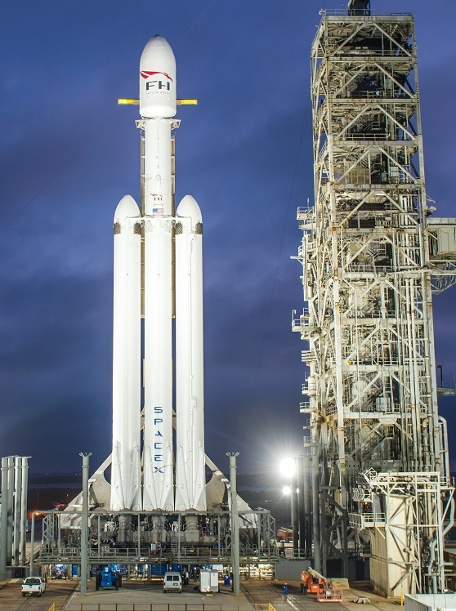

Starship Super Heavy: 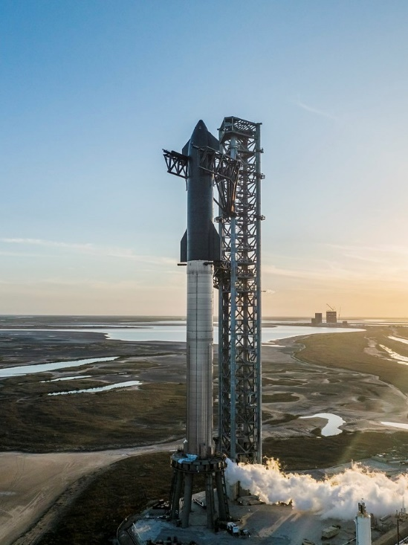

**Rocket Lab**

Electron: 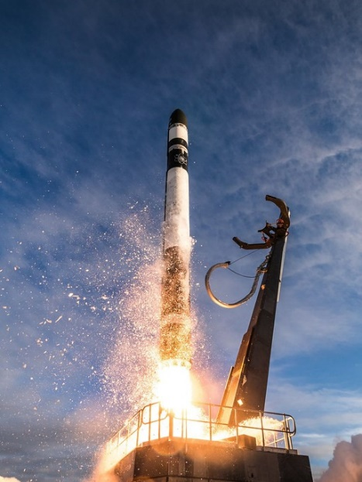

**NASA**

**ULA**

**Ariane Space**

**Blue Origin**

**

